Rural Road Connectivity Progress under PMGSY:
A Machine-Learning-Based Typology of Indian States and Union Territories
Madhumita Maan|24570035
Department of Computer Science, Ramanujan College, University of Delhi
Course: Machine Learning | B.Sc. (Hons.) Computer Science | Semester V
Article Type: Original Research / ML Application Assignment

Abstract
Rural road connectivity is an important component of inclusive development because it improves access to markets, education, healthcare and public services. The Pradhan Mantri Gram Sadak Yojana (PMGSY) is a major Government of India programme for providing all-weather rural road connectivity. This study examines the state- and Union Territory-wise variation in completed PMGSY road length during 2021–22, 2022–23 and 2023–24 and develops a data-driven typology using unsupervised machine-learning methods. The dataset contains 32 State/UT observations and three annual completion measures, reported in kilometres by the Ministry of Rural Development. Annual road-completion values are standardised before applying K-means and agglomerative hierarchical clustering. A linear trend slope is also calculated for each State/UT to represent the direction and rate of change over the three-year period. The number of clusters is selected by comparing silhouette scores for k = 2 to 5. The analysis is intended to distinguish high-volume, moderate, low-volume and changing implementation profiles rather than rank states solely by total kilometres. Results must be interpreted in the context of differences in geography, population, terrain, project mix and programme implementation capacity. The study provides a reproducible undergraduate-level application of data preprocessing, feature scaling, clustering, trend analysis and cluster validation.
Keywords: PMGSY; rural roads; state typology; K-means; hierarchical clustering; silhouette score; unsupervised learning; SDG 9; SDG 11

1. Introduction
Rural connectivity is a basic infrastructure requirement for economic and social development. In many rural areas, road access determines how easily residents can reach schools, hospitals, markets, banks and administrative services. Better connectivity can reduce travel time, improve the movement of agricultural produce, support local employment and strengthen access to essential services.
The Pradhan Mantri Gram Sadak Yojana (PMGSY), launched in 2000, aims to provide all-weather road connectivity to eligible unconnected rural habitations. Its implementation involves multiple programme verticals and state-level agencies. However, implementation progress is not uniform: States/UTs differ in geographical area, terrain, population distribution, existing road networks, administrative capacity and the scale of sanctioned works.
A simple ranking by completed kilometres does not fully describe these differences. Machine learning can help identify groups of States/UTs with similar completion patterns. This project uses unsupervised learning to classify States/UTs into broad progress profiles based on annual completed road length and its trend. The work is aligned with SDG 9 (Industry, Innovation and Infrastructure) and SDG 11 (Sustainable Cities and Communities).
Objectives: (i) compare completed PMGSY road length across States/UTs for three financial years; (ii) calculate a linear trend slope for each State/UT; (iii) apply K-means and hierarchical clustering; (iv) select a suitable cluster count using silhouette analysis; and (v) interpret the resulting groups as implementation typologies.

2. Related Work and Policy Context
The PMGSY programme is monitored through the Ministry of Rural Development and the Online Management, Monitoring and Accounting System (OMMAS). Government replies to Parliament publish state-wise sanctioned and completed road lengths, which provide a transparent basis for comparative analysis. The Ministry has also described the programme’s focus on eligible habitations, use of new and green technologies, and maintenance responsibilities of State/UT Governments.
Clustering is a standard unsupervised-learning technique used to group observations without predefined class labels. K-means partitions observations by minimising within-cluster squared Euclidean distance. Hierarchical clustering builds a nested grouping structure and, with Ward linkage, merges clusters to minimise the increase in within-cluster variance. The silhouette coefficient measures how well an observation fits its own cluster compared with the nearest alternative cluster.

3. Dataset and Preprocessing

3.1 Data source and scope
The primary dataset was transcribed from the Ministry of Rural Development / Press Information Bureau release dated 4 February 2025, titled “Construction of roads under Pradhan Mantri Gram Sadak Yojna”. Annexure-I reports State/UT-wise road length completed (km) for 2021–22, 2022–23 and 2023–24. The dataset contains 32 State/UT records and 3 annual numeric variables. The 2024–25 financial year is not included in the clustering because the cited three-year annexure does not provide a complete comparable 2024–25 annual column. A separate later district-level dataset extends to 2024–25, but it has a different granularity and should not be mixed with the state-level table without aggregation and validation.
Unit of measurement: kilometres of road length completed during the financial year. A value of zero is retained as a reported zero, not treated as missing.

3.2 Variables
Variable | Type | Description | Role
State_UT | Categorical | Name of State or Union Territory | Identifier
2021-22 | Numeric | Road length completed in km | Feature
2022-23 | Numeric | Road length completed in km | Feature
2023-24 | Numeric | Road length completed in km | Feature
Trend_slope_km_per_year | Numeric | OLS slope fitted across the three annual observations | Derived feature

3.3 Cleaning and feature engineering
State/UT names are retained as identifiers and are not passed directly into the distance calculation. The three annual completion columns are converted to numeric values. The three-year total and mean annual completion are calculated for descriptive analysis. For each State/UT, a simple linear regression is fitted with time indices t = 0, 1, 2 and annual completion as the dependent variable. Its coefficient is the trend slope in km/year. Positive slopes indicate increasing completion across the observed period; negative slopes indicate decreasing completion.
Because the annual values and trend slope are measured in kilometres and can have very different magnitudes, StandardScaler is applied before clustering. For each feature, z = (x − μ)/σ, where μ and σ are estimated across the 32 observations. Scaling prevents a feature with a larger numeric range from dominating Euclidean distance.
Normalisation limitation: the primary state-wise table reports absolute completed kilometres, not state area or population. Therefore, the main clustering uses absolute completion and trend. A per-area or per-capita comparison requires joining a separate, consistently defined state-area/population table (for example, Census 2011 population) and should be reported as a sensitivity analysis rather than silently treating absolute kilometres as a rate.

4. Methodology

4.1 K-means clustering
K-means partitions the standardised feature vectors into k clusters. It minimises the within-cluster sum of squares:
J = Σ(k=1 to K) Σ(xᵢ ∈ Cₖ) ||xᵢ − μₖ||²
where Cₖ is cluster k and μₖ is its centroid. The algorithm is initialised with k-means++ and repeated with multiple initialisations. A fixed random_state = 42 is used to make the analysis reproducible.

4.2 Hierarchical clustering
Agglomerative hierarchical clustering starts with each State/UT as a separate cluster and repeatedly merges the closest pair. Ward linkage selects the merge that produces the smallest increase in within-cluster variance. The final solution is cut at the same k selected for K-means so that the two methods can be compared.

4.3 Trend analysis and cluster validation
The trend slope is the coefficient β₁ in yₜ = β₀ + β₁t + εₜ. A positive β₁ indicates an upward trend in completed road length; a negative β₁ indicates a downward trend. The silhouette coefficient for observation i is s(i) = [b(i) − a(i)] / max(a(i), b(i)), where a(i) is its average distance to observations in its own cluster and b(i) is the lowest average distance to another cluster. Values close to 1 indicate well-separated clusters; values near 0 indicate overlapping clusters; negative values suggest possible misassignment.

4.4 Workflow
Step | Operation
1 | Load the state-wise annual completion dataset
2 | Validate data types and retain reported zeros
3 | Calculate three-year total, mean and trend slope
4 | Standardise annual completion values and trend slope
5 | Evaluate K-means for k = 2, 3, 4 and 5 using silhouette score
6 | Fit K-means and Ward hierarchical clustering using selected k
7 | Compare cluster membership and interpret cluster profiles
8 | Export results and visualisations

5. Experimental Setup
Software: Python 3; pandas and NumPy for data handling; scikit-learn for scaling, regression and clustering; Matplotlib for visualisation. The experiment is unsupervised, so there is no train-test split and no target class label. The analysis uses all 32 State/UT observations.
Reproducibility settings: K-means random_state = 42; n_init = 20; candidate cluster counts k = 2, 3, 4, 5; hierarchical linkage = Ward. The selected k is the candidate with the maximum silhouette score. The script supplied with this report prints the exact scores and exports the final cluster labels.

6. Results and Analysis
The three-year total completed road length across all States/UTs is 97,850 km based on the tabulated observations. The largest three-year totals are shown in Table 2. The table describes absolute completion and should not be interpreted as a per-capita or per-area performance ranking.
State/UT | 2021–22 (km) | 2022–23 (km) | 2023–24 (km) | Total (km) | Trend (km/yr)
Uttar Pradesh | 3,368 | 5,011 | 6,799 | 15,178 | 1,715.5
Madhya Pradesh | 4,444 | 3,732 | 910 | 9,086 | -1,767.0
Odisha | 2,819 | 2,668 | 2,589 | 8,076 | -115.0
Bihar | 1,862 | 1,961 | 2,251 | 6,074 | 194.5
Rajasthan | 3,255 | 544 | 1,669 | 5,468 | -793.0
Jammu And Kashmir | 3,278 | 464 | 956 | 4,698 | -1,161.0
Karnataka | 2,560 | 1,629 | 457 | 4,646 | -1,051.5
Chhattisgarh | 3,034 | 670 | 201 | 3,905 | -1,416.5
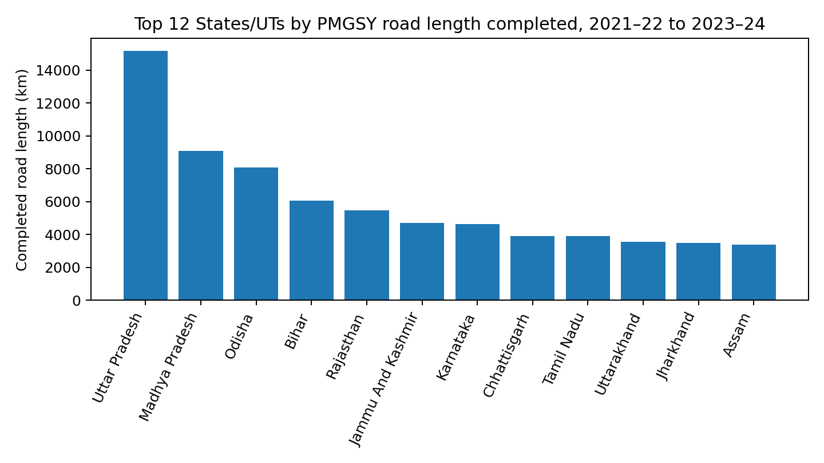
Figure 1. States/UTs with the highest cumulative completed road length over the three-year study period.

6.1 Cluster selection
Silhouette scores are computed for k = 2 to 5. The candidate with the highest score is selected as the primary K-means solution. Since silhouette values depend on feature choice and scaling, the selected value is a diagnostic aid and not proof that the data have naturally separated groups.
Candidate k | Silhouette score
2 | 0.713
3 | 0.470
4 | 0.461
5 | 0.482
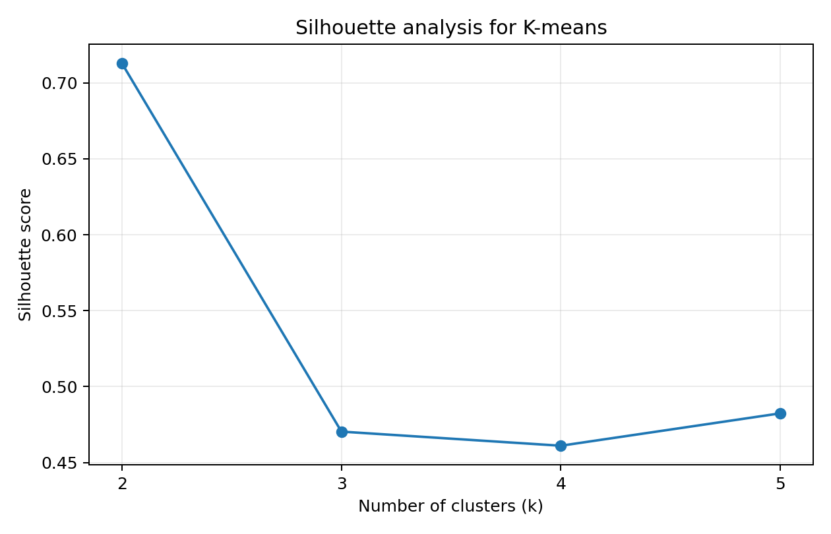
Figure 2. Silhouette score comparison for candidate K-means cluster counts.

6.2 Interpreting clusters
Cluster labels are arbitrary identifiers and do not represent ranks. To interpret a cluster, compare its mean annual completed road length, mean trend slope and member States/UTs. A cluster with a high mean and positive slope may be described as a high-volume/increasing profile; a low mean with a near-zero slope may be described as a low-volume/stable profile. A cluster with a negative mean slope may represent a declining or variable completion profile. These descriptions must be assigned after inspecting the exported cluster summary, not from the numeric label alone.
On the current feature matrix, the selected number of clusters is k = 2. The K-means silhouette score at this k is 0.713; the Ward hierarchical solution evaluated at the same number of clusters has silhouette score 0.713. The accompanying Python file reproduces these values and prints cluster membership for interpretation.

7. Discussion
The analysis demonstrates how a small state-level dataset can be transformed into an exploratory typology using standard undergraduate machine-learning methods. Annual values preserve the pattern across years, while the trend slope summarises direction of change. K-means provides compact centroid-based groups, whereas hierarchical clustering provides an alternative grouping based on successive merges. Agreement between the two methods increases confidence that a broad grouping is not solely an artefact of one algorithm.
However, completed kilometres are an output measure and are influenced by the scale of the State/UT, terrain, population distribution, number of eligible habitations, existing connectivity, sanctioned project pipeline and implementation capacity. Large states may naturally complete more kilometres than small states. Consequently, this study does not equate a large absolute total with better efficiency. A stronger follow-up analysis should calculate completed kilometres per 1,000 sq. km and per lakh rural population, and may also examine completion as a proportion of sanctioned length. Such indicators require additional, harmonised denominator data.
Limitations: (i) only three annual observations are used; (ii) the main state-wise table contains absolute road length rather than per-area or per-capita rates; (iii) the 2024–25 year is excluded from the main analysis because the selected official annexure provides a comparable complete three-year series only through 2023–24; (iv) the dataset does not distinguish road quality, maintenance status, cost or beneficiary outcomes; and (v) cluster assignments may change with the selected features, scaling method and k.

8. Conclusion and Future Work
This project applies K-means and agglomerative hierarchical clustering to State/UT-wise PMGSY road completion data for 2021–22 to 2023–24. It combines annual completion values with a linear trend slope and uses silhouette analysis to select a cluster count. The resulting typology is an exploratory tool for comparing broad implementation patterns, not a definitive performance ranking. Future work should extend the time series, incorporate the 2024–25 district-level records after careful aggregation, add state area and rural population denominators, include sanctioned road length and expenditure, and examine whether cluster membership is stable under alternative feature sets.

Declarations
Data availability. The state-wise annual completion figures are transcribed from the Ministry of Rural Development / Press Information Bureau release dated 4 February 2025, Annexure-I. A machine-readable CSV and reproducible Python script are supplied with this report.
Conflict of interest. The author declares no conflict of interest.
Funding. No external funding was received.
Use of AI tools. AI assistance was used to help draft and format the report and code. The student should run the supplied code, verify the output, check the source data and revise this declaration to accurately describe all tools used.

References
[1] Press Information Bureau, Ministry of Rural Development, Government of India, “Construction of roads under Pradhan Mantri Gram Sadak Yojna,” 4 February 2025. Available: https://www.pib.gov.in/Pressreleaseshare.aspx?PRID=2099775
[2] Ministry of Rural Development, Government of India, “Pradhan Mantri Gram Sadak Yojana (PMGSY),” official programme information and OMMAS portal. Available: https://pmgsy.dord.gov.in/
[3] S. P. Lloyd, “Least squares quantization in PCM,” IEEE Transactions on Information Theory, vol. 28, no. 2, pp. 129–137, 1982.
[4] J. MacQueen, “Some methods for classification and analysis of multivariate observations,” in Proceedings of the Fifth Berkeley Symposium on Mathematical Statistics and Probability, 1967, pp. 281–297.
[5] P. J. Rousseeuw, “Silhouettes: A graphical aid to the interpretation and validation of cluster analysis,” Journal of Computational and Applied Mathematics, vol. 20, pp. 53–65, 1987.
[6] F. Pedregosa et al., “Scikit-learn: Machine learning in Python,” Journal of Machine Learning Research, vol. 12, pp. 2825–2830, 2011.

Appendix A. Dataset extract
The complete 32-row CSV is supplied separately. The first rows are shown below as a format illustration.
State/UT | 2021–22 | 2022–23 | 2023–24
Andaman And Nicobar | 14 | 31 | 43
Andhra Pradesh | 1282 | 1051 | 369
Arunachal Pradesh | 598 | 1183 | 303
Assam | 2164 | 624 | 610
Bihar | 1862 | 1961 | 2251
Chhattisgarh | 3034 | 670 | 201
Goa | 0 | 0 | 0
Gujarat | 1009 | 824 | 619
Haryana | 1384 | 414 | 344
Himachal Pradesh | 1624 | 1126 | 317

Appendix B. Reproducibility
Place pmgsy_state_year_data.csv and pmgsy_clustering.py in the same folder. Install the packages listed in the script header and run: python pmgsy_clustering.py. The program prints silhouette scores, selected k and cluster assignments, and writes pmgsy_clustered_results.csv and pmgsy_cluster_plot.png.

